Please follow these images and make these selections to reset the device back into Eloview Mode:

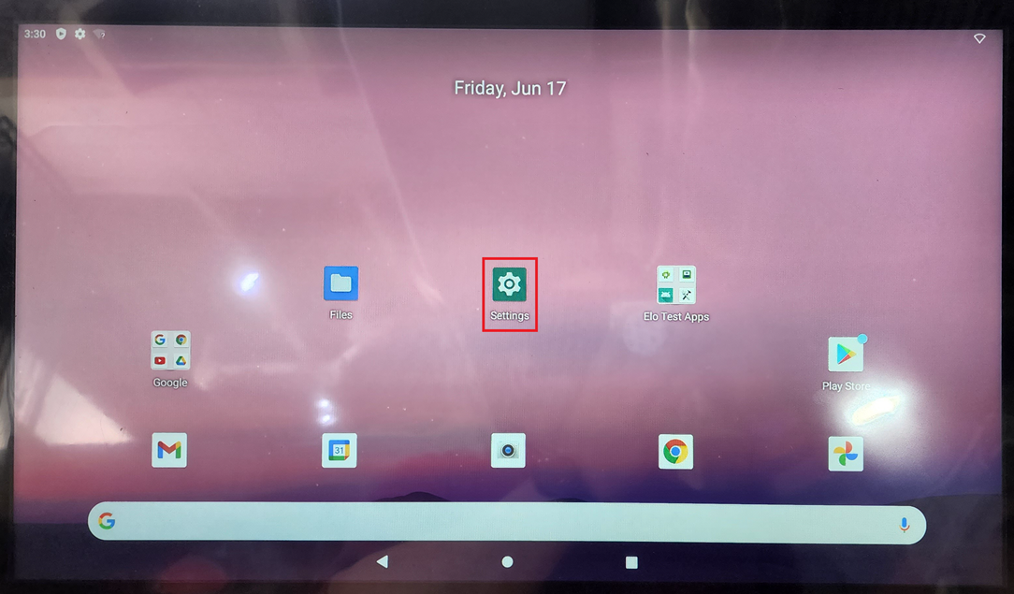

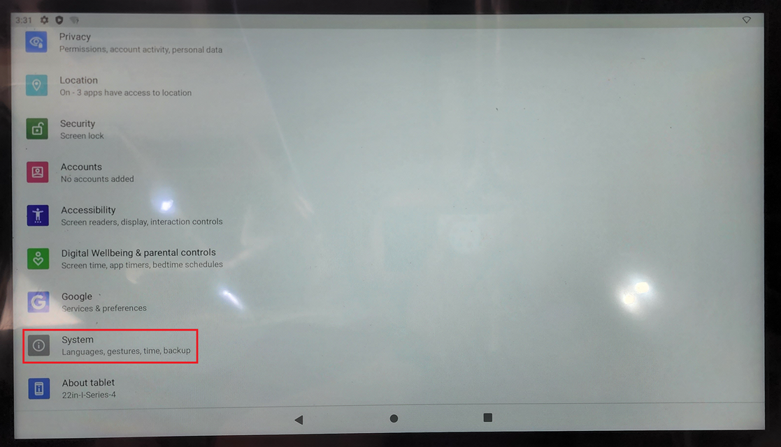

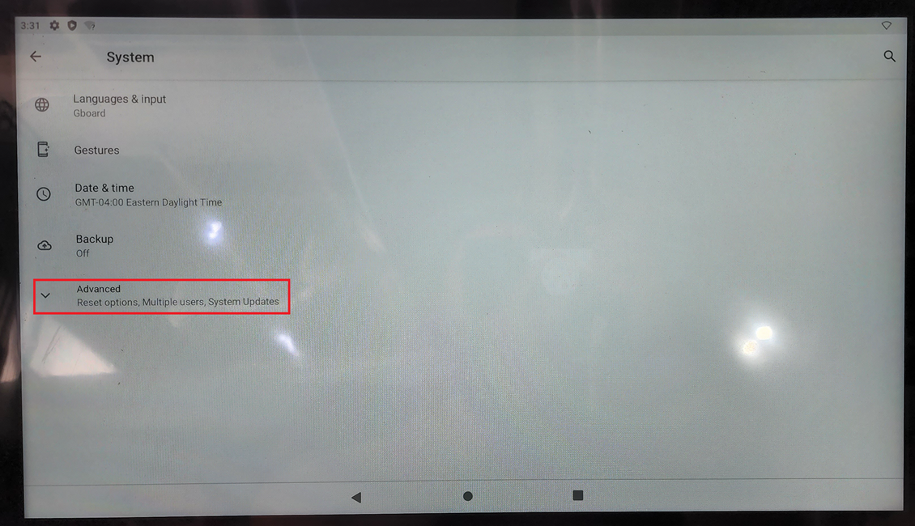

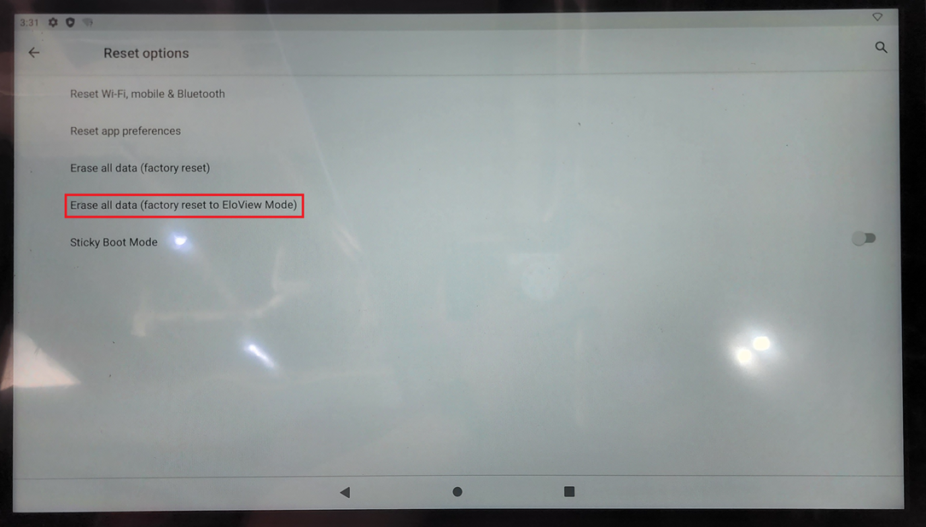

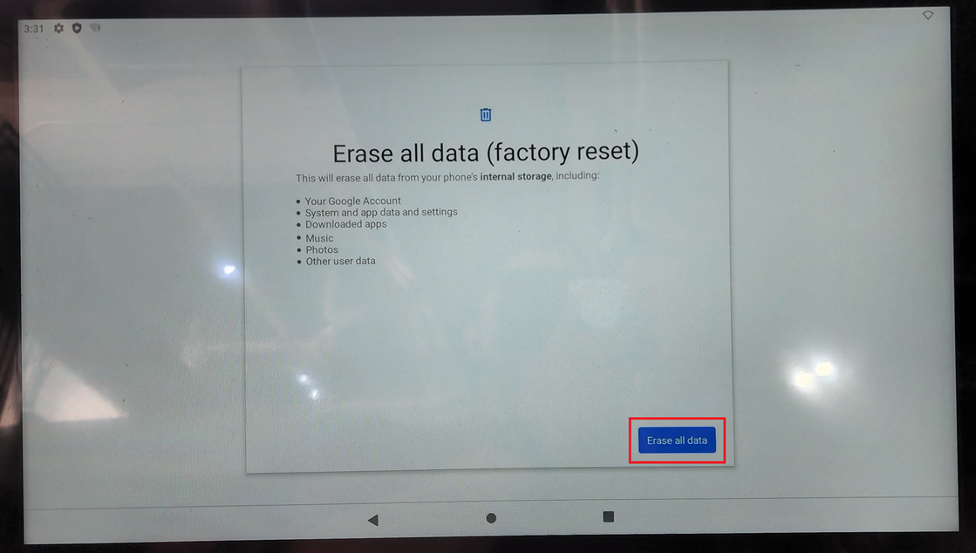

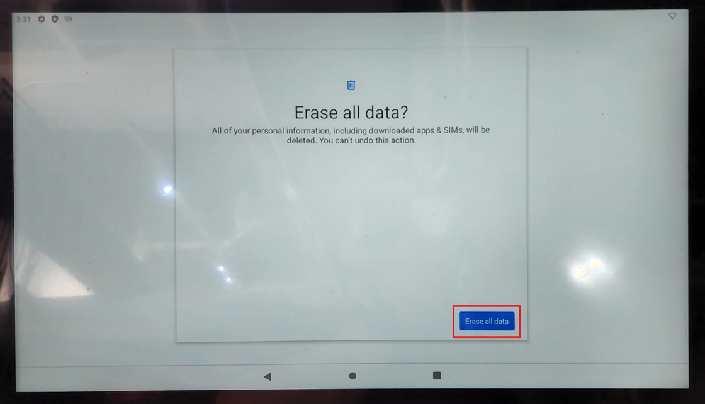

From here it should reboot and come back up to the screen below. It is imperative that “enroll with EloView” is selected. From there, you will need to connect to wi-fi if the device is not connected to a network with internet access via ethernet.

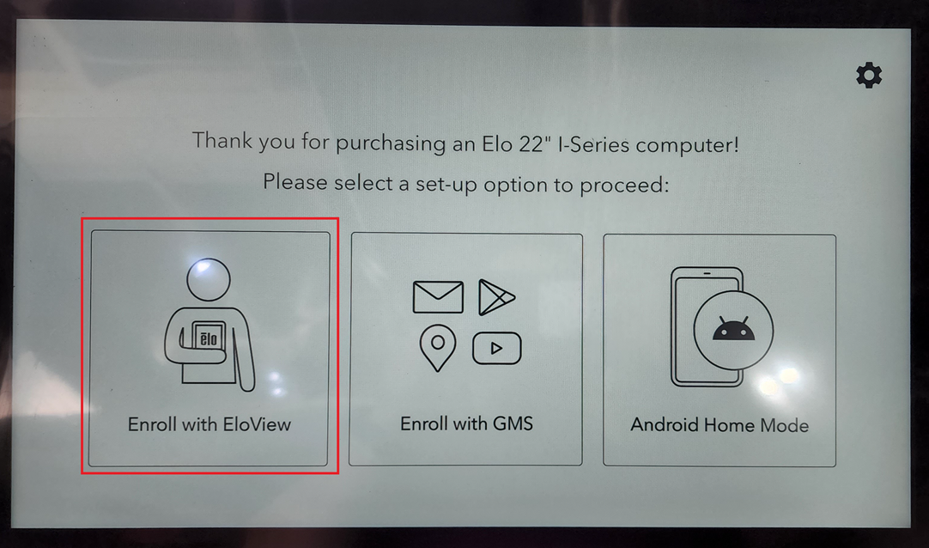

Once you get to the EloView login page, stop there and no not log in. Contact support and we will re-push the software package to the device from our management portal.