Quest Web Services / Tapin2 Enhancement
Tapin2 is used to access Quest Web Services over the Internet. Limited security is provided by setting firewall rules to limit IP addresses that can access the Web Services.
It is desired to maintain communication between the application and Quest Web Services Without incoming connections from the Internet to the Web Services server. Current implementation uses firewall rules to allow specific incoming connection based on IP address and port. If this can be done by using an outbound connection from the Web Services server then the firewall rules should no longer be necessary, at least on the Web Services side.
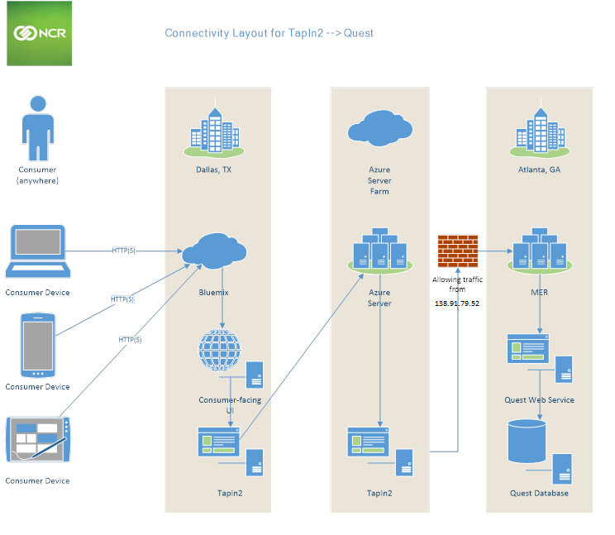

Soap Proxy with Reverse Connection Service
The following diagram represents the system. Web service requests are directed to a local Quest Web Service Proxy, which exactly mirrors the signature of the actual Quest Web Service. Each Web Service call is posted to the local Web Server (IIS) using SOAP XML. The SOAP XML is intercepted prior to calling the Proxy web service, and routed to the actual “Store” web service via a “Reverse Call” mechanism, which is implemented as a “Call management” web service in the same package as the QuestMenu Proxy web service, and another service that runs on the “Store” machine where the real Quest Web Service resides. These services stay connected using requests initiated by a service running on the “Store” server.
Multiple instances of the proxy app can be used to support multiple stores on a single web server. To do this copy the application files into separate folders (one folder per store) and add each folder as a separate application in IIS.
The “Reverse Call” services scenario works as follows:
- The “Reverse Call Service” Client on the Web Service (Store) machine establishes invokes the “Call Management” web service on the Quest Web Services Proxy machine (App Server) by calling its DoReverseCall() method.
- The “Call Management” service does not reply to the call right away. It waits for a SOAP request from IIS before returning. (though it could return early due to timeout)
- When the application makes a Quest Web Service call, its SOAP XML is intercepted by the Proxy Web service and sent to the “Call Management” web service.
- The “Call Management” Web Service sends the SOAP XML to the client as a “reply” to the earlier DoReverseCall() call
- The client will “POST” the SOAP request to the local IIS server.
- IIS will invoke the actual Quest Web Service and return its response
- The Client service will relay the response to the “Call Management” web service
- “Call Management” returns the response to the function that originally intercepted the SOAP XML
- The SOAP XML response will be returned to the application
Note this is a simplified overview. Additional steps are implemented to improve reliability, performance and security, among other things. In addition, all proxy components can be configured to write to a log file for diagnostic purposes.
A fully functioning version of the system has been developed as “Proof of Concept”. This works as desired with my testing. Additional testing is welcome and recommended.
The Proof of Concept system includes the following:
- The Proxy Web Service mirrors the QuestMenu web service, intercepts SOAP XML and sends it into the Reverse Call mechanism.
- I updated the Proxy Web Service that mirrors the standard QuestMenu, and added a new Call Management web service that implements the reverse calling scheme. It has one primary method to do the reverse call. Its input argument can include the return value of a prior call. After delivering the prior return value, it acts as a listener for new calls, until a timeout expires. This service supports multiple simultaneous calls, and multiple listeners to keep thing moving.
- A console app that implements the “Reverse Call Service” can be used to bridge the Proxy to an existing Quest Web Service, and monitor its activity on the console. It calls the reverse-call web service, posts any xml returned by that service, and sends return xml on a subsequent connection. It loops to keep the connection active (and keep its listener available on the server). The App can start any number of processing threads to get calls started as soon as they arrive, and process multiple calls simultaneously. This will be a Windows service, optionally writing progress to a log file in the final implementation.
- A PostSoap utility provides the ability to send Soap XML to the Proxy (or production) service using the command line. It can also display or save the formatted results. This can be used in a bat file to send several requests in a row, and simultaneously run bat files in different consoles to simulate multiple clients.
- A GUI test application that exercises many of the available web services calls may be used to verify functionality. The test app can be directed to use any Quest Web Service or Proxy service as desired.

