
Venue Manager

Tapn2 Inseat/Kiosk Build

Location
The location build does not change for Tapn2.
- Stock Family needs to contain all saleable items for this location.
- Location can do standsheets if needed.
- Tipping options, service charge, clerk mode or SQL host do not need to be set up.

Web Terminal-Location
Tapin2 will need a terminal created in Quest and linked to the location and walkabout keypad.
- To create a terminal for the Kiosk or Inseat location
  - Select the organization module and Terminal Tab
  - Select New in the upper right hand corner
  - When the Web Service option appears, select OK.
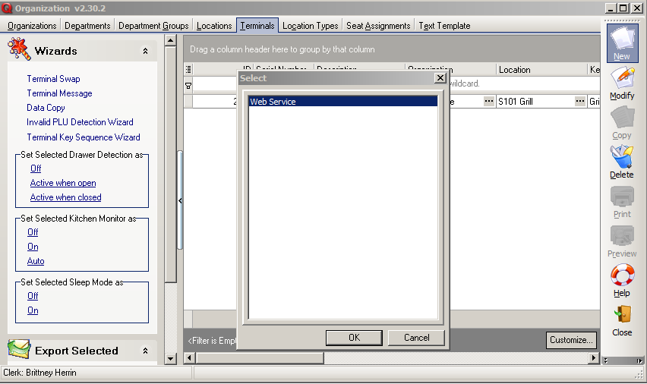

  - QVM will auto generate a Device Id (Tapin2 will need this ID number).
  - Next, assign the terminal a location and a walkabout keypad with the items sold.
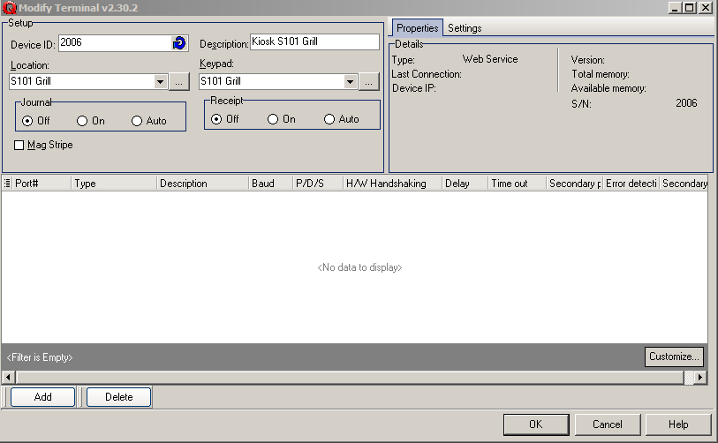

Web Terminal- Printing
Tapin2 needs 1 terminal configured per Tapin2 printer.
- If a Quest location is printing food and drink separately, you will need to create separate web terminals with the corresponding food and drink keypads.
- If there is only one printer that will handle both food and drink then the location web terminal can be used.

Walkabout Keypad
The keypad needs to contain all saleable items or if needed for remote printing, then only the items that will be needed for that printer.

Creating a Walkabout Keypad
- Open the Keypad module and select the Keypad tab.
- Open the Advanced options panel on the left side and select your organization
- Select New from the toolbar.
- Select the Walkabout option and select Ok.
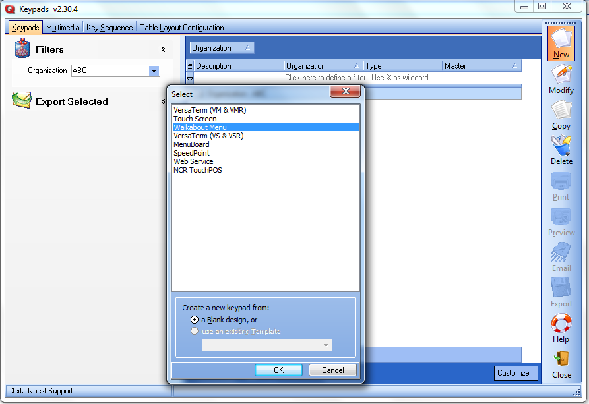

- Add a description for the keypad in the description field in the upper right hand corner. It is recommended for the keypad and location to have similar descriptions. NOTE: Suite Catering Online- the decsriptions put on the buttons is what will show to the customer online. They will list alphabetically and not the order that they have been placed on the keypad.
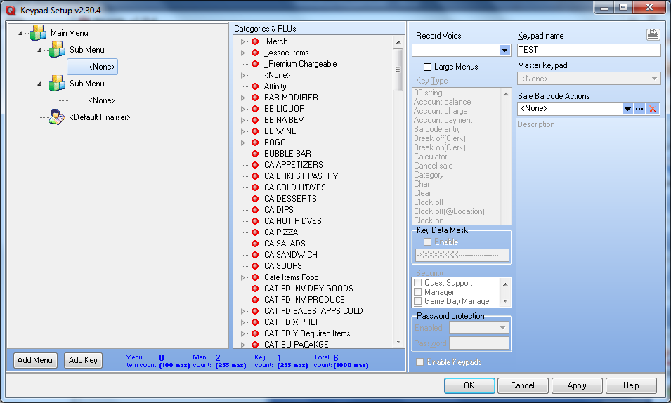

Adding Sub Menu buttons
Think of Sub Menus as way to organize product on the keypad. Think of Food, NA Bev, Liquor. For any web use of the walkabout keypad including Suite Cateing online, only one level of sub menus are allowed.
- Click on Main Menu at top of keypad and then select the Sub Menu button from the bottom left of the page.
- This will add a sub menu to the keypad.
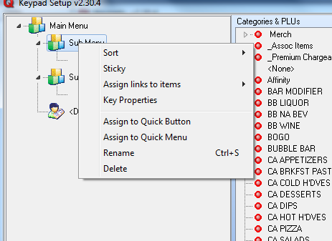
- Right clicking on the Sub Menu will being up an option to rename the button.

- Repeat this process for every sub menu you need to have on the keypad.
- If you prefer them in a particular order you can left click>hold the left click, then drag and drop the menu in a different order.
Adding Item to Sub Menus
Items can be added individually or by category. Any combination of items and catgeories of items can be added under a sub menu.
BY ITEM
- Under the Category & PLU listing, find the category the individual item is in and click on the arrow to the left of the category name. This will expand the category.
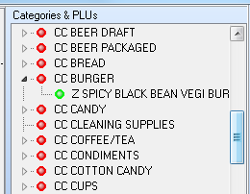
- Left click and hold, drag the item and release under the sub menu the item will sit under.
- The item will show green in the Category and PLUs list if it is on the keypad.
- The item will show under the sub menu with a red pie icon. This identifies that it has been put on the keypad as an individual item.
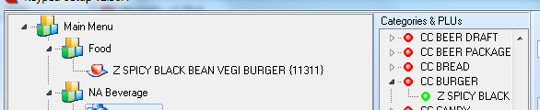
- Repeat this process as needed to add multiple items to any category.

- Select OK to save the keypad.

Modifier linking for Tapn2 Inseat and Kisoks
This process is only for Tapn2 inseat and kisosk setup with QVM. This does not apply to Suite Catering online.
Modifier Set up notes
- Set up modifiers per normal setup, include in the stock family and have a price set on the price level for the inseat location even if it is $0.
- The category does not need to be flagged as instructional nor does the modifiying category need to be linked to the parent item in the back office. The linking via the walkabout keypad defines the linked items as the modifiers.
- Only one category can be linked at a time via the keypad so plan the modifying categories out ahead of time.

Keypad set up
- Add items to keypad, either individually or by category.
- Linking modifiers can happen at the item/category of item level or at the Sub Menu level.
- To do so, right click on the item/category or Sub Menu
- Choose the Link (option at product level) or Assign Links to Items (option at Sub menu Level)

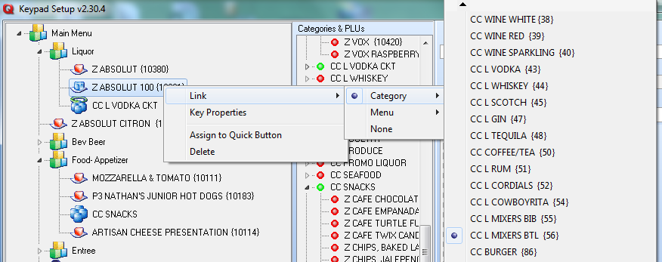
- Select Category option and category of modifier from the list that appears.

- Each item/catgory of items could have a different modifier category linked to them. If it is done via the sub menu a message will appear. Select OK to continue or the red X to stop the action.

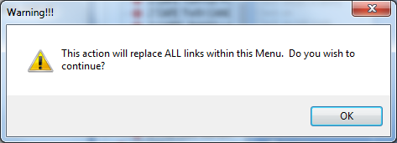
- When an individual Item has a link the red icon will turn blue.
- When a category of items has a link it will have a halo above it.

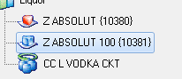
- To unlink Items- right lick and select none from the list
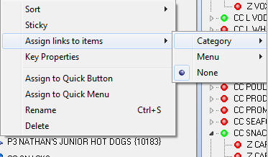
- Select OK to save Keypad when finished.

