Table of Contents
MICROS SERVER & NETWORK CONFIGURATION
TAPIN2 ADMIN CONFIGURATION
MICROS MENU CONFIGURATION
SYNCING DATA FROM MICROS TO TAPIN2
SERVICE CHARGES/FEES, TIPS, & TAXES
TAPIN2 SALES SUBMISSION TO MICROS
MICROS CHECK RANGE SETTINGS
TROUBLESHOOTING TIPS
ADDITIONAL INFORMATION

MICROS SERVER & NETWORK CONFIGURATION
- Micros Simphony Transaction Services
  - Venue will need Simphony Transaction Services installed to facilitate the integration
    - Venue will need to setup a server for Transaction Services to be installed on
    - Venue will need to engage MICROS/Reseller Resource to install and configure Transaction Services API for Tapin2 integration
      - Tapin2 environment will need to communicate to the client environment via the Transaction Services API URL over Port 443 (HTTPS). Communication will then need to be routed to the server’s internal IP address over Port 8080 (HTTP). A load balancer is needed to facilitate this communication.
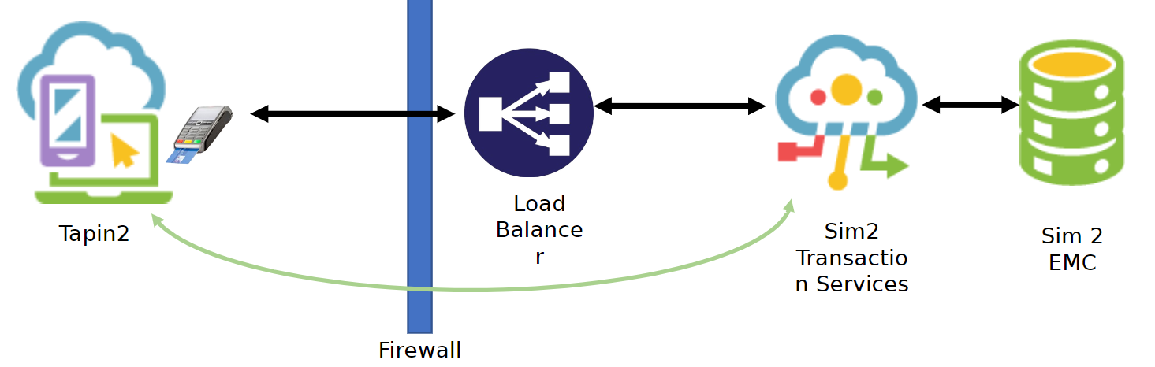
      - There is a maximum of 8 Micros Revenue Centers (RVC) per Transaction Services server. If more than 8 revenue centers are being used for the integration, the venue will need a Transaction Services Server per every 8 RVCs.
  - Venue to provide Tapin2 public facing Transaction Services API URL(s)
  - Venue to provide Tapin2 list of MICROS Revenue Center names & IDs for each RVC Tapin2 will be integrated with.
  - Venue to provide Employee Object Number to Tapin2. This is a virtual user in the system with access to the Transaction Services API. Only one Employee Object ID is needed for the entire venue
  - Venue will need to configure Tapin2 specific Tender Media types in Micros and provide the Tender Media ID(s) to Tapin2. If using multiple tender types denote which IDs belong to each tender type.
    - Examples:
      - Tapin2=301
      - Visa=302
      - MasterCard=303
      - AmericanExpress=304
      - Discover=305
      - Loyalty=306 (Givex, Fortress, Lava, Stadis, etc..)
      - Tappit=307
  - Venue will need to configure Service Charges for Fees & Tips in Micros and provide the Service Charge IDs to Tapin2 (If applicable)

- Tapin2 IP Addresses - Venue IT will need to Whitelist the following Tapin2 IP Addresses
  - Primary Azure App Server
    - 13.77.176.66
  - Outbound Azure Apps Ips
    - 13.77.162.15
    - 13.66.163.227
    - 13.66.158.57
    - 13.66.165.49
    - 13.66.175.2
    - 13.66.163.18
    - 13.77.161.12
    - 13.77.160.237
  - Tapin2 Internal Test Environments
    - 138.91.79.52
    - 20.57.134.152
    - 45.50.41.1

TAPIN2 ADMIN CONFIGURATION
- Tapin2 Venue Integration Settings
  - Tapin2 to configure Venue POS Integration Settings for MICROS SIM2 in the Tapin2 environment using the Transaction Services API URL(s), Tender Media ID(s), Service Charge ID(s) & Employee Object Number provided by the Venue
    - If using multiple instances of Transaction Services use the URL of the first server
  - Clients will need to provide all of this information from Micros. Including creating TenderMediaID.
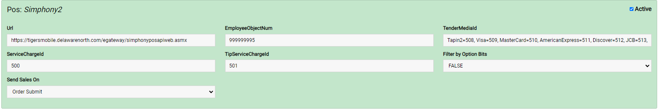

- Tapin2 Location Integration Settings
  - Tapin2 to configure Venue POS Integration Settings for MICROS SIM2 in the Tapin2 environment using the following information:
    - RVC ID(s)
    - Transaction Services API URL(s)
    - Employee Object Number
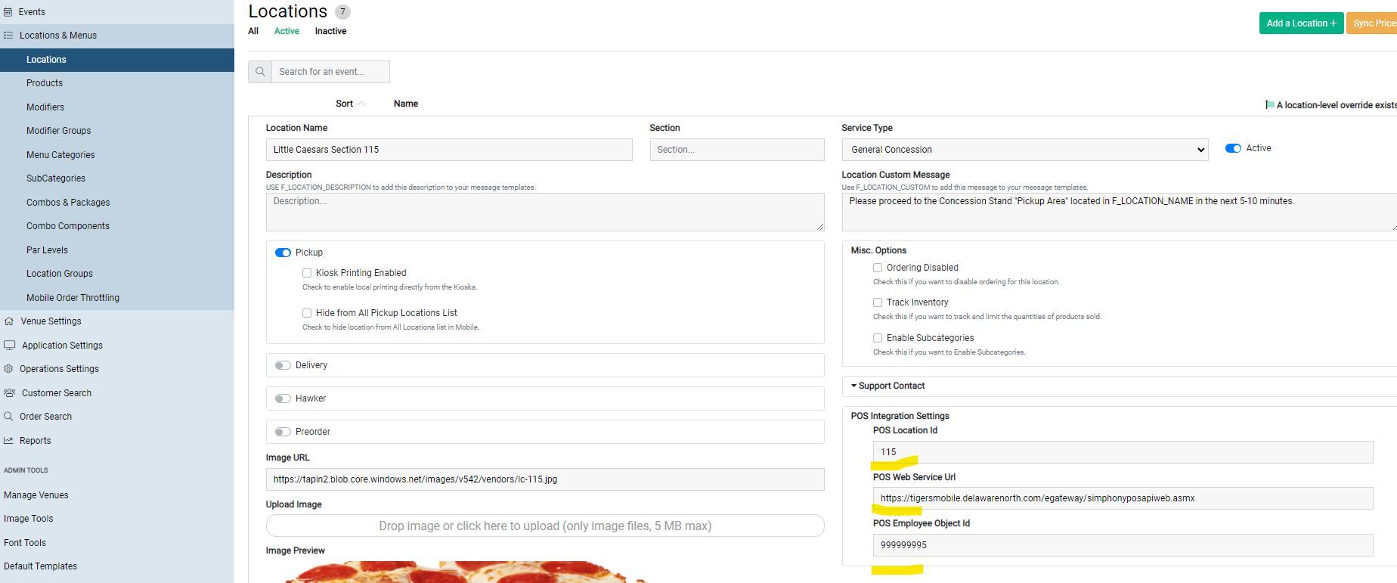

MICROS MENU CONFIGURATION
- Venue to determine which RVCs will be used for Tapin2 and provide list of RVC numbers & corresponding Location names to Tapin2

- Venue to Sync all menu items from SIMVEN to Micros RVCs in EMC

- Venue to confirm all menu Item Definitions that need to be synced to Tapin2 are in their respective RVCs
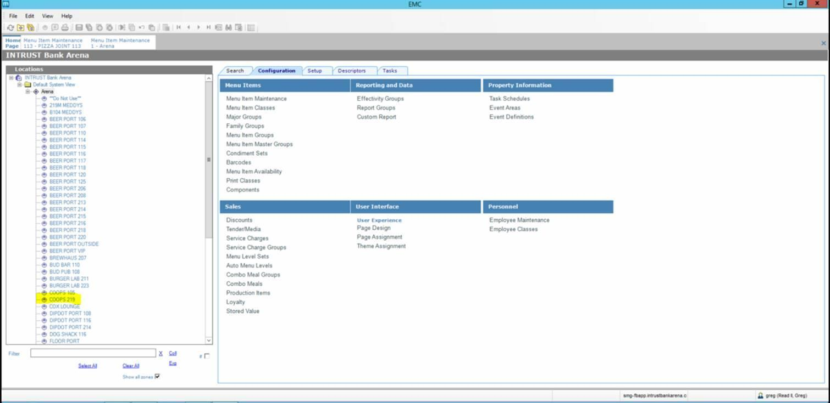

- Product Pricing - A product in Micros cannot be in different RVCs with different prices. Therefore, a new product must be created if the product has different prices across RVCs (e.g. $0.00 soda in premium vs $6.00 soda in concessions will need to different menu items definitions.
- Product Configuration - Venue will need enter a 0 (zero) into the 3rd Name field for all the Menu Item Definitions in each RVC that are to be synced to Tapin2. Adding a zero to this field allows Tapin2 to filter for the correct menu items to sync over within each RVC in EMC.
- Modifier (Condiments in Micros) Configuration - Venue will need to enter MOD into the 3rd name for all menu item definitions in each RVC that are to be synced to Tapin2. Adding a MOD in this field allows Tapin2 to filter for the correct mods to sync over within each RVC in EMC. Anything with MOD in the 3rd name will pull into Tapin2 as a modifier in Tapin2.

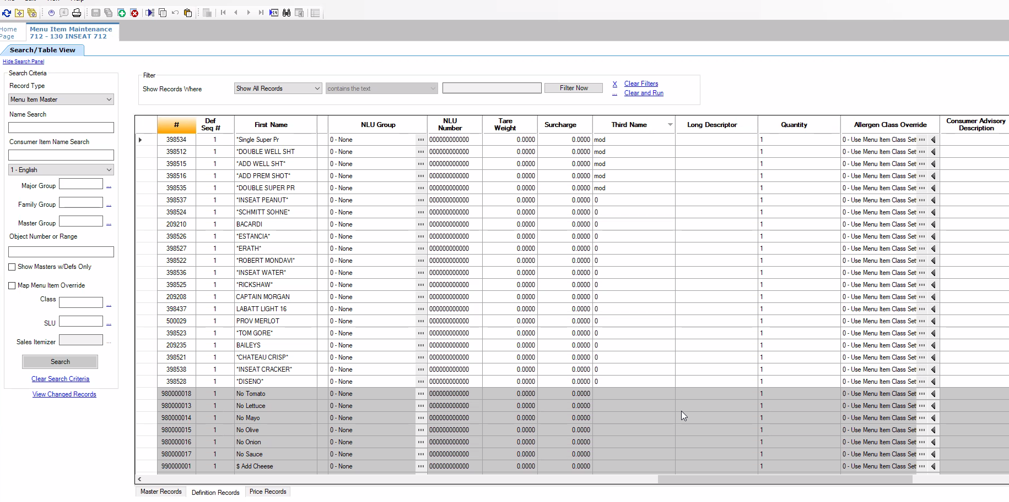

- Modifiers/Condiments Menu item Class – To configure modifiers in Micros for the integration the venue will need to create a Menu Item Class wherein all items are designated as condiments with zero tax. (See picture below)
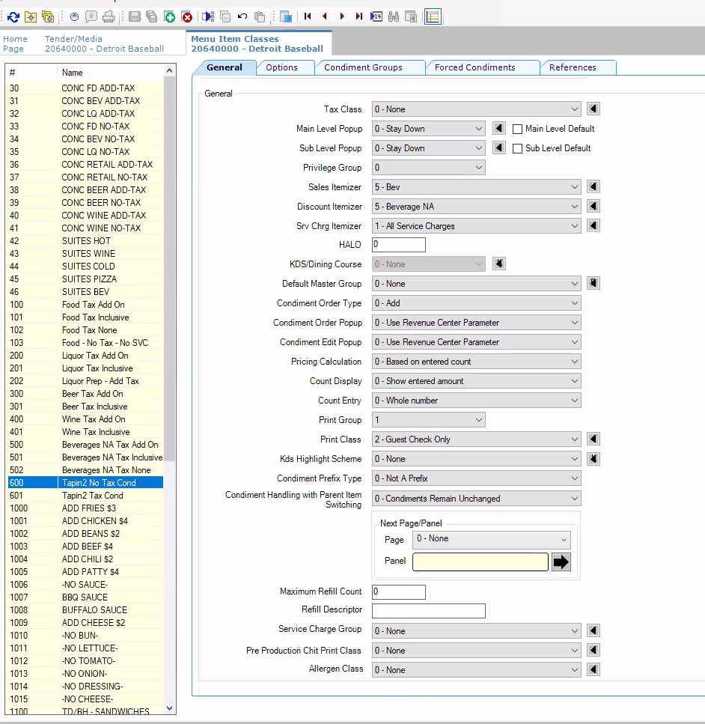

SYNCING DATA FROM MICROS TO TAPIN2
SYNCING PRODUCTS & MODIFIERS
- After all integration settings have been configured in Micros & Tapin2 the Menu Sync will be functional. In the Tapin2 Admin go to the Locations page and click the SYNC button for the Location Menu that would like to sync over
- Tapin2 will now begin to process the Menu Sync for that location. A pop-up will appear with a list of Menu Changes to be synced. On the pop-up Menu Sync screen you are able to Select All Changes or alternatively check the boxes for the specific type of menu change(s) you want to add and uncheck the type of change(s) you do not want to sync over. You can also check and uncheck changes on an individual basis. When all of the desired menu changes are checked and you are ready to finalize the Menu Sync press the SYNC MENU button. The Menu Sync will now process & finalize the changes
  - When syncing modifiers you need uncheck the Modifier All Changes check boxes and select the individual Mods you want to sync over. Leaving the All Changes check boxes checked for Mods will result in the Mod Groups becoming disassociated with their products in Tapin2, if this happens the Mod Groups will need to be manually re-assigned to their respective products
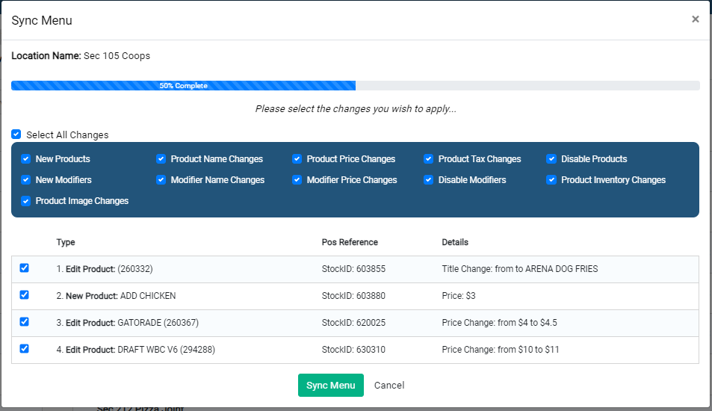

- When the Menu Sync is complete it will say “100% Menu Sync Complete” in the pop-up at which point you can click OK.
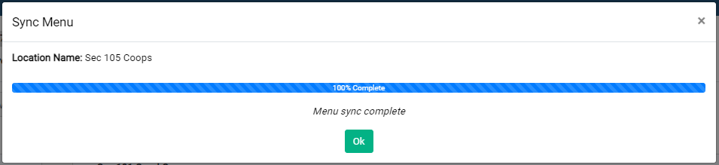
- The Menu Sync is now complete for this location. Please repeat the steps to sync additional locations. Once a Menu has been Synced you can edit the Product Settings in Tapin2, including Menu Categories, Product Types, the Sort Order in which products appear, Kiosk/Mobile Images etc. When finished configuring the items be sure to click the Apply Updates button(s) for your app(s). Please reference the Tapin2 Knowledge Base for more information on configuring Products & Modifiers. Tapin2 Knowledge Base: https://tapin2support.zendesk.com/
  - PLEASE NOTE:
  - Menu Categories DO NOT sync over. They will need to be manually created in Tapin2 and Products will need to be manually added to them
  - Modifier Groups DO sync over with Modifiers
  - After Modifiers have been synced over they will not be automatically attached to their respective product(s). Modifier Groups will need to be manually associated to products in Tapin2.

SYNCING PRICES – Prices must match between Micros and Tapin2 in order to send the orders to Micros
- Go to the Locations page and click the Sync Prices button
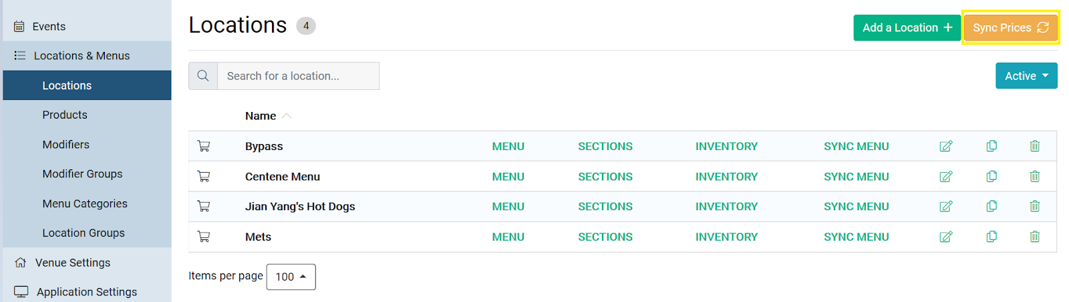

- A pop up will appear for you to select the Locations you want to perform the price sync for. There is a select all option as well. When done selecting locations click the Start Sync button to begin processing the price changes
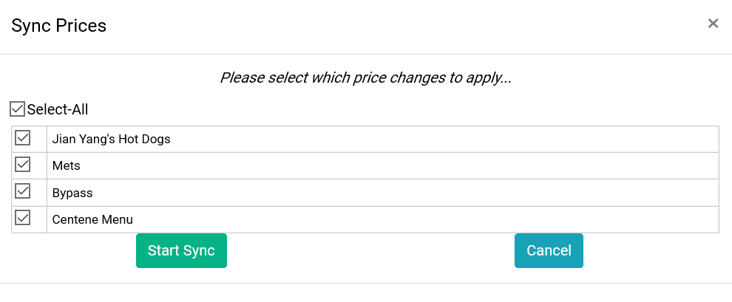
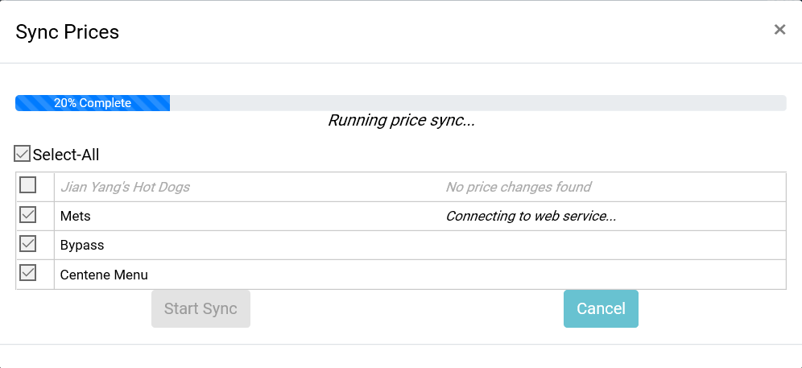
- When the Price Sync has completed reading the incoming Price Changes it will display how many Pending Prices Changes there are per location. Click Apply Changes to finalize the Price Sync
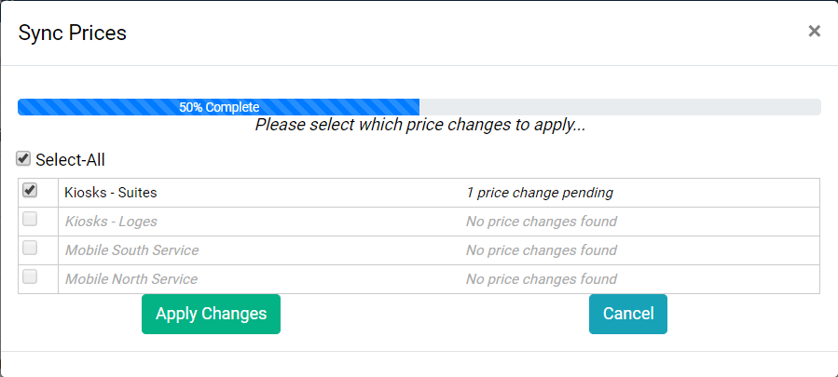

- When the Price Sync has finished changing the prices in Tapin2 it will say 100% Price Sync Complete at which point you can click OK to close the window.
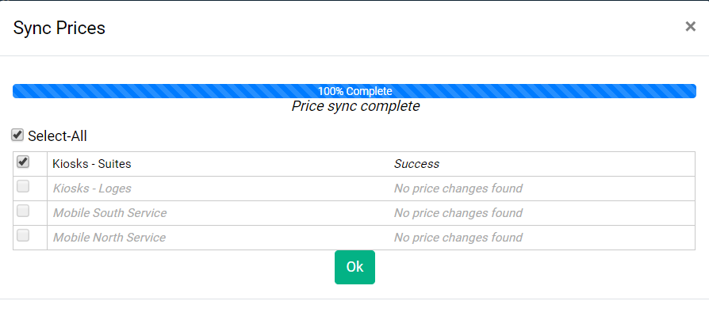
- Under Admin Tools click the Apply Updates button for each of your apps for the price changes to take effect in the web app.
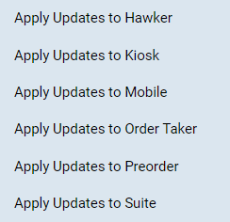

SERVICE CHARGES/FEES, TIPS, & TAXES

TAXES – It is imperative to have the same settings in Micros as there are in Tapin2
  - Inclusive vs Exclusive Taxes – Determine if Tax is inclusive or exclusive to the prices. The tax settings must mirror each other in both systems, this includes the Tax Percentage Rate AND which items those taxes are applied to.
    - Having the wrong settings in inclusive and exclusive taxes on either side will result in orders failing to successfully send to Micros which will affect Reporting accuracy and may result in financial loss.
    - To configure the venue for Tax Inclusive Pricing go to Venue Settings, check the box that says Tax Included in Price, and Save. Leave the check box unchecked for Exclusive Taxes.
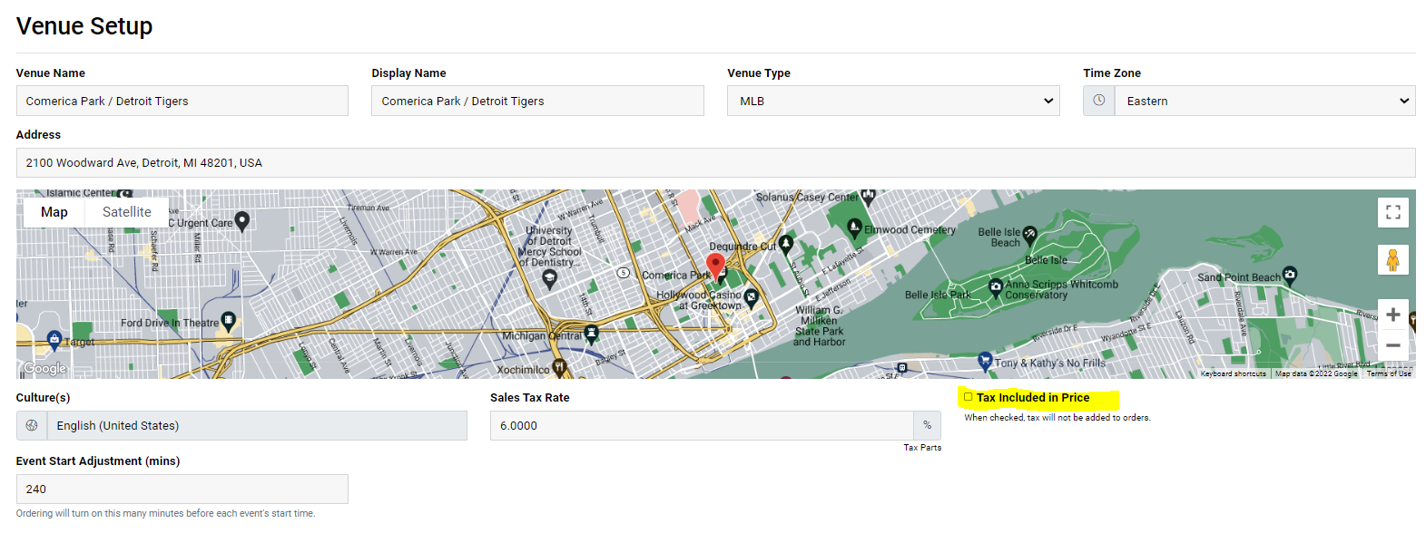

SERVICE FEES/CHARGES
- If the Venue is charging Service Fees they will need to be configured in Tapin2 & Micros
  - Tapin2 Service Fee Configuration
    - The Fees can be set to a Flat Rate and/or a Percentage of the amount of each order
    - Fees are configured separately per each App
    - Fees are configured separately for Pick Up or Delivery service
    - Determine if Service Fee is included in the price. If the Fee is included in the price check the box that says Service Fee Included in Price. If the Fee is not included in price leave the check box blank.
    - Determine if Service Fee is taxable. If the Fee is subject to Sales Tax check the box that says Fee Subject to Sales Tax. If the Fee is not subject to Sales Tax leave the check box blank.
      - PLEASE NOTE: Even if a sale is a penny off from what Micros is expecting the sale will not send to Micros
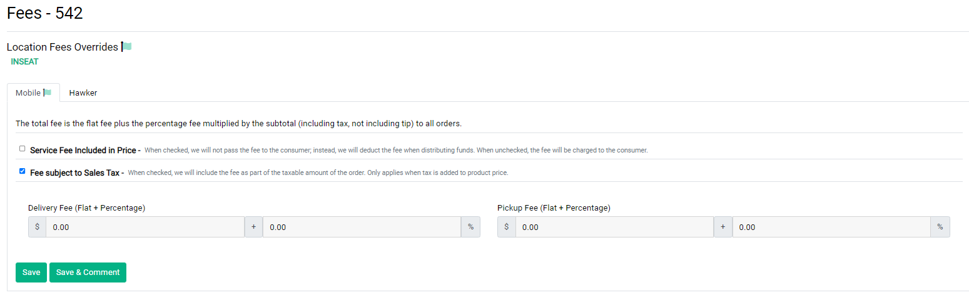

  - Micros Service Fee Configuration
    - Client will need to configure Service Charges in Micros EMC
    - Service Charge IDs must be created in Micros (see screen shot below for # 500)
    - If Service Charges are subject to tax they will need to be configured in Micros accordingly
    - DO NOT set Service Charges in Micros to a percentage, this will result in the Integration failing to send orders to Micros. The Service Charges need to be set to OPEN for Micros to be able to receive orders with Service Charges from Tapin2.
    - Service Charges need to be applied to the RVCs in Micros that will be charging them.

- PLEASE NOTE: For more detail on Service Charges in Micros please see Page 138 in the Oracle-Symphony Training guide (Screen shot below)
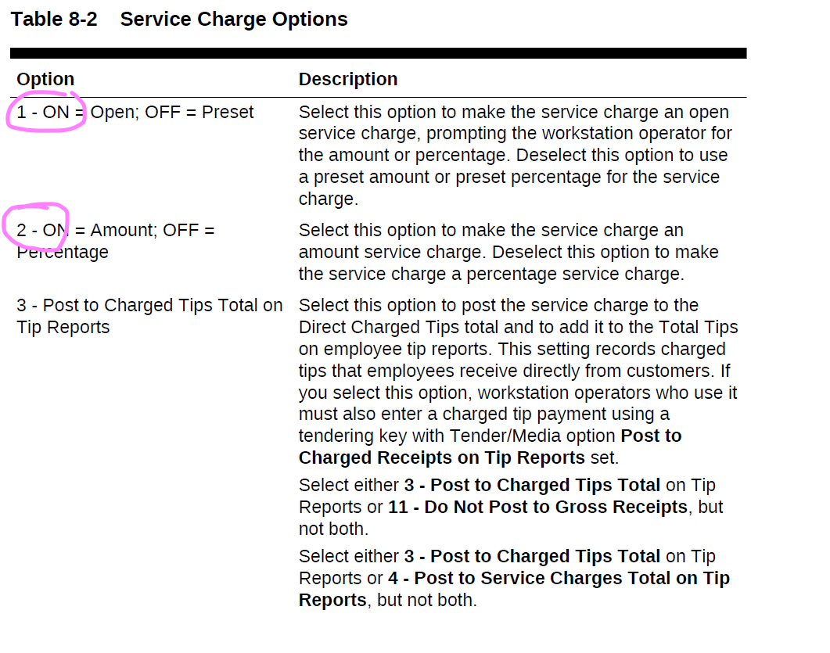
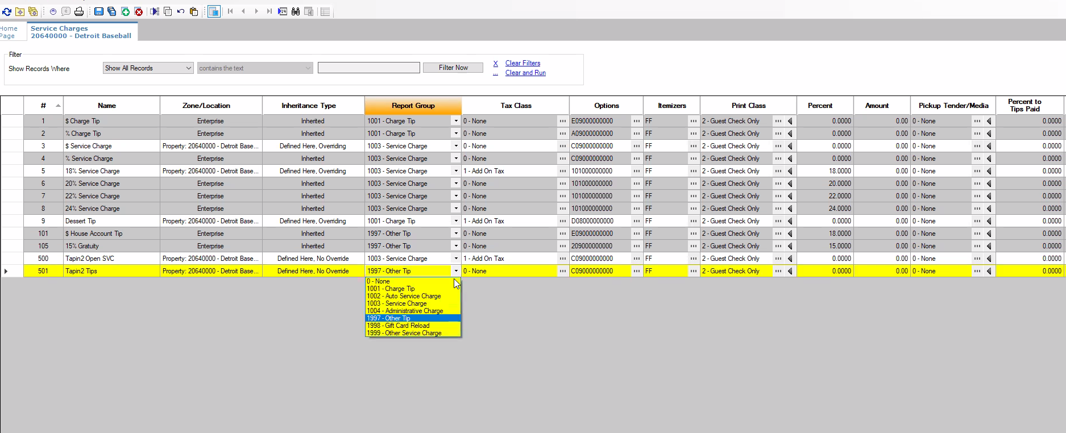

TIPS
- In Micros, Tips are a type of Service Charge. A Service Charge for Tips will need to be created in Micros and configured for OTHER TIP
  - The Tip Service Charge should NOT be taxable and should be set up the same as regular service charges in this regard. See Service Charge #501 Tips set up in screenshot above for example.
- Tips Service Charge needs to be applied to the RVCs in Micros that will allow tipping
- A Print Class for Tips needs to be created in Micros and then assigned to the Tips Service Charge under General Settings in order for Tapin2 to know where to send the tipped amounts per sale.
- The Report Group called Charge Tip needs to be assigned to the Tips Service Charge under General Settings
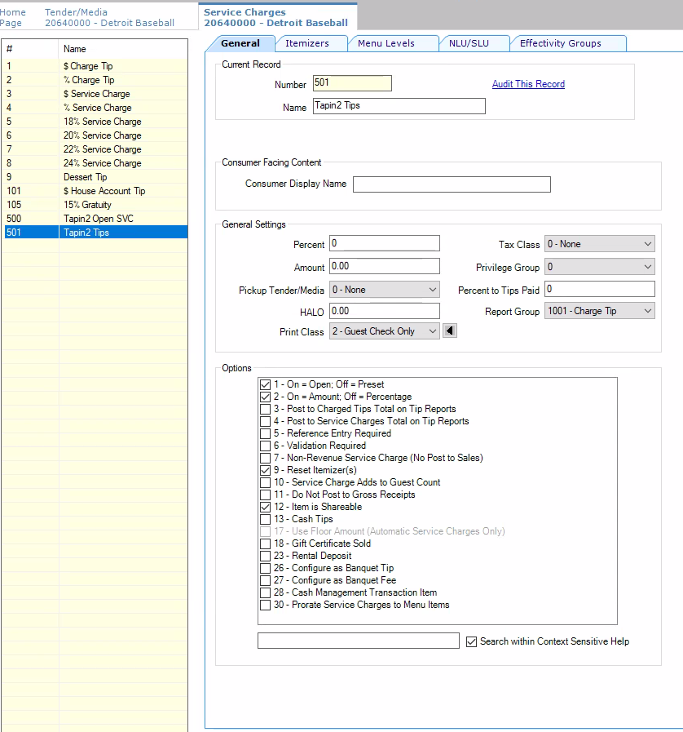

TAPIN2 SALES SUBMISSION TO MICROS
- To confirm Sales are successfully sending to MICROS a test transaction will need to be performed.
- Once a transaction has been performed, go to the Events Dashboard page in the Tapin2 Admin Portal and look under the POS Status column.
  - If the status reads “Sale Sent” then the sale has been sent to Micros and will appear in reports.
  - If the status reads as “Sale Failed” then there is an issue with the integration that will need to be troubleshot.
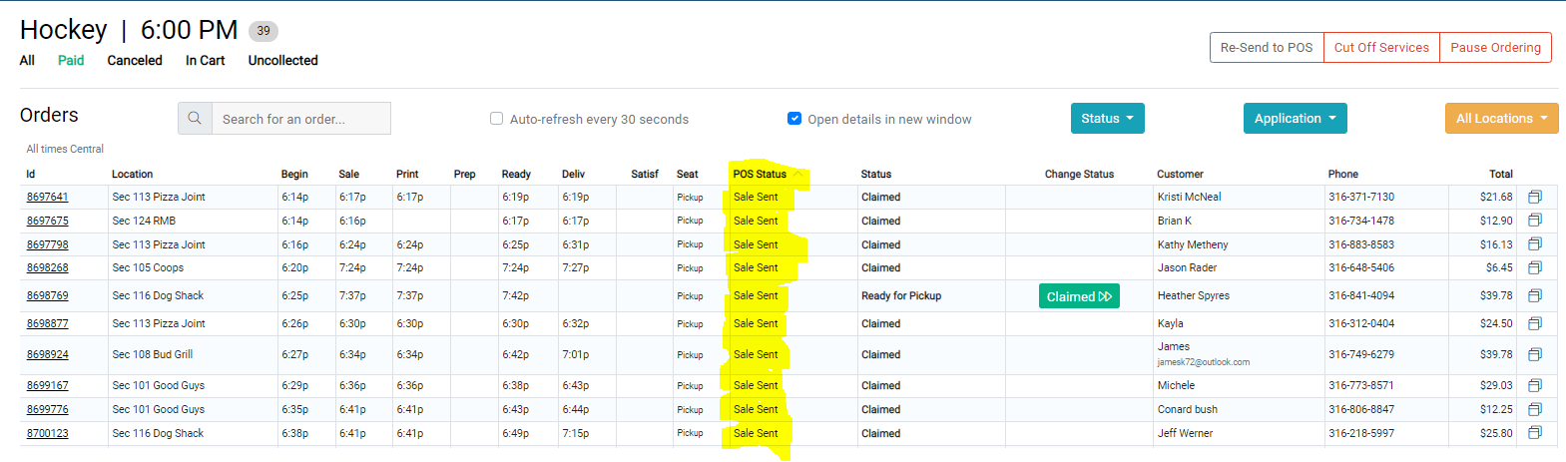
  - If the status reads “Sale Failed” then there is an issue with the integration that will need to be troubleshot.
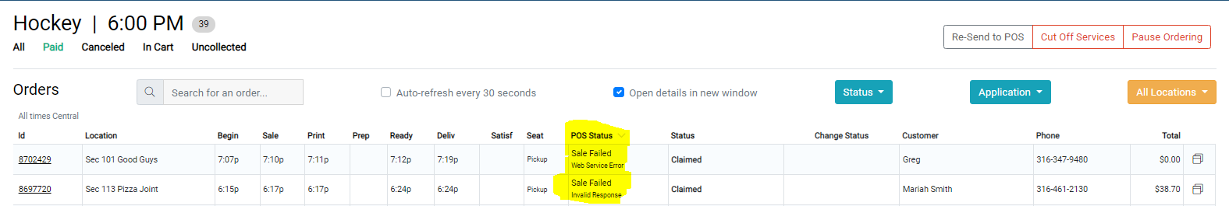

- Tapin2 will work with Venue to confirm that sales show up as expected in Micros Reporting. The Order Detail Report should be reviewed to confirm the items ordered, the total amount of the order, tender media, etc…

MICROS CHECK RANGE SETTINGS
- Check Range Micros needs to be expanded to 10k per day for each RVC. It is extremely likely more check numbers will be used than you expect.
  - Not having enough Checks available will cause sales to fail to report to Micros
  - Check Numbers are pulled by control module or Transaction server and not by RVCs. Don’t be scared to make more than needed check numbers, expanding the check range will not cause any issues

TROUBLESHOOTING TIPS
- Transaction Services may be down/offline if Tapin2 is unable to sync menus and send sales. In this instance confirm the server is online and Transaction Services service is running
- Integration Log Error meanings:
  - Check Number is Invalid – Not enough available checks in RVC. Check Range needs to be expanded.
  - Underpayment – Tapin2 is sending over less than Micros is expecting. Most likely a configuration issue in Micros or Tapin2. Start troubleshooting by reviewing the configurations for Taxes, Service Fees, & Product/Mod Price

